步骤：

准备三台linux虚拟机，安装完成后设置ip。或者使用我共享的虚拟机，vmware，复制成3台，分别设置好虚拟机。使用NAT方式。

***虚拟机软件****：windows使用vmware workstation 9，网盘里有共享的安装文件和注册机*

*mac使用vmware fushion，可以搜索下载*

***镜像文件****：可以使用我共享的centos7虚拟机ovf文件导入，需要重新设置ip，copy一下成为N台虚拟机即可。安装完后记得做个快照，防止将系统搞坏。也可以使用我提供的centos7的安装镜像自己重新安装。*

*下载地址：*

# *链接: https://pan.baidu.com/s/1O8SxwHolh3Kb6nQplVnu-g 密码: 5u8j* centos7虚拟机的配置：

centos7虚拟机的密码：root/123qwe

## 1.1 网络模式设置【vmware fushion mac版】：

### vmware fusion的网络NAT模式[MAC OS]

**进去以下目录：**

|  |
| --- |
| cd /Library/Preferences/VMware Fusion |

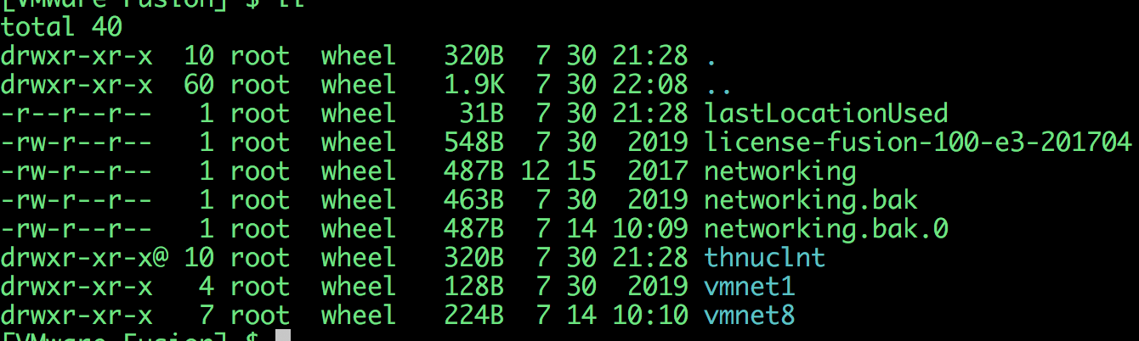

**将vmnet8的配置改为如下,编辑networking：如果没有vmnet8则新增一个：按照以下配置：**

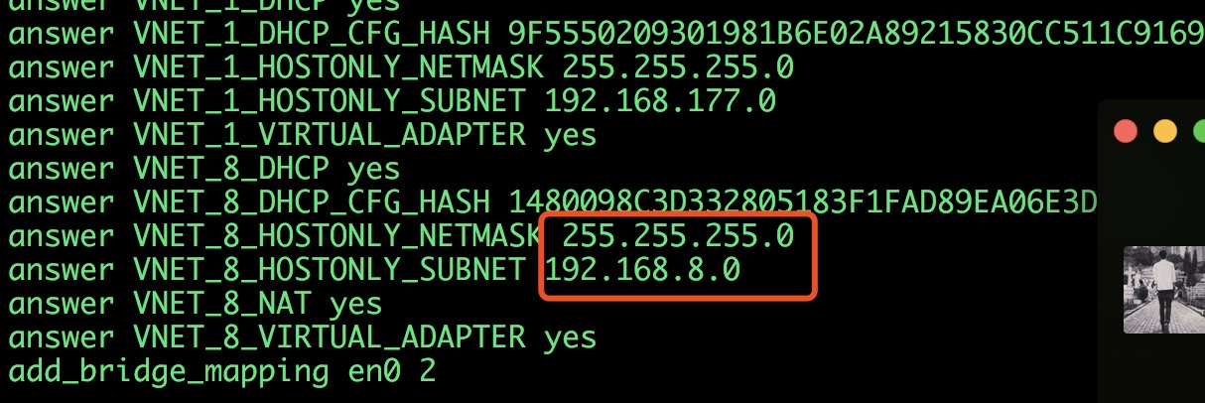

**回到当前目录，进入vmnet8子目录：**

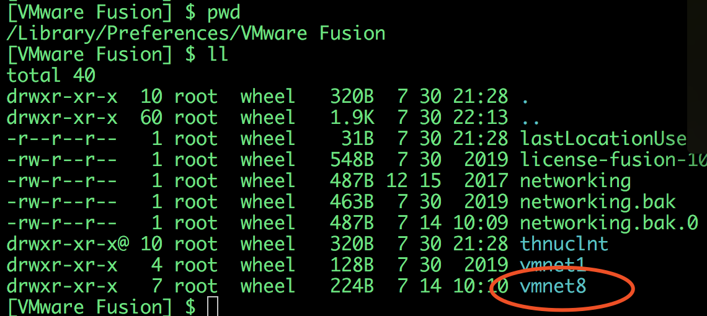

**该目录下有以下文件：**

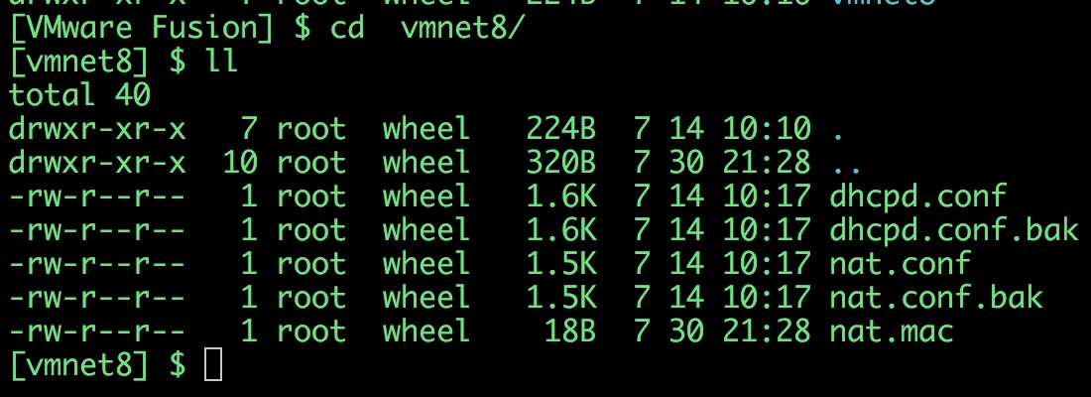

**首先，修改dhcpd.conf文件内容如下：**

|  |
| --- |
| # Written at: 07/14/2020 10:17:51  allow unknown-clients;  default-lease-time 1800; # default is 30 minutes  max-lease-time 7200; # default is 2 hours  subnet 192.168.8.0 netmask 255.255.255.0 {  range 192.168.8.128 192.168.8.254;  option broadcast-address 192.168.8.255;  option domain-name-servers 192.168.8.2;  option domain-name localdomain;  default-lease-time 1800; # default is 30 minutes  max-lease-time 7200; # default is 2 hours  option netbios-name-servers 192.168.8.2;  option routers 192.168.8.2;  }  host vmnet8 {  hardware ethernet 00:50:56:C0:00:08;  fixed-address 192.168.8.1;  option domain-name-servers 0.0.0.0;  option domain-name "";  option routers 0.0.0.0;  } |

**修改nat.conf如下：**

|  |
| --- |
| # VMware NAT configuration file  # Manual editing of this file is not recommended. Using UI is preferred.  [host]  # NAT gateway address  ip = 192.168.8.2  netmask = 255.255.255.0  # VMnet device if not specified on command line  device = vmnet8  # Allow PORT/EPRT FTP commands (they need incoming TCP stream ...)  activeFTP = 1  # Allows the source to have any OUI. Turn this on if you change the OUI  # in the MAC address of your virtual machines.  allowAnyOUI = 1  # Controls if (TCP) connections should be reset when the adapter they are  # bound to goes down  resetConnectionOnLinkDown = 1  # Controls if (TCP) connection should be reset when guest packet's destination  # is NAT's IP address  resetConnectionOnDestLocalHost = 1  # Controls if enable nat ipv6  natIp6Enable = 0  # Controls if enable nat ipv6  natIp6Prefix = fd15:4ba5:5a2b:1008::/64  [tcp]  # Value of timeout in TCP TIME_WAIT state, in seconds  timeWaitTimeout = 30  [udp]  # Timeout in seconds. Dynamically-created UDP mappings will purged if  # idle for this duration of time 0 = no timeout, default = 60; real  # value might be up to 100% longer  timeout = 60  [netbios]  # Timeout for NBNS queries.  nbnsTimeout = 2  # Number of retries for each NBNS query.  nbnsRetries = 3  # Timeout for NBDS queries.  nbnsTimeout = 2  # Number of retries for each NBNS query.  nbnsRetries = 3  # Timeout for NBDS queries.  nbdsTimeout = 3  [incomingtcp]  # Use these with care - anyone can enter into your VM through these...  # The format and example are as follows:  #<external port number> = <VM's IP address>:<VM's port number>  #8080 = 172.16.3.128:80  [incomingudp]  # UDP port forwarding example  #6000 = 172.16.3.0:6001 |

**然后重启虚拟网络：**

|  |
| --- |
| sudo /Applications/VMware\ Fusion.app/Contents/Library/vmnet-cli --stop  sudo /Applications/VMware\ Fusion.app/Contents/Library/vmnet-cli --start |

**查看一下ifconfig：**

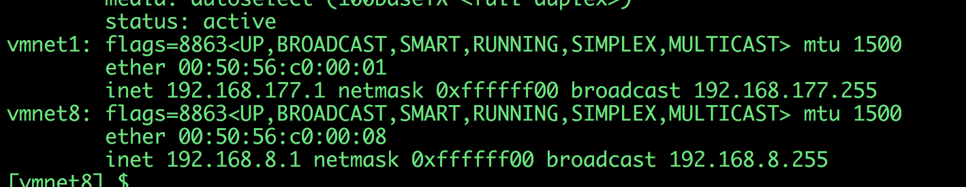

**查看vmbet8是否有ip且未192.168.8.1，且能ping通说明配置成功：**

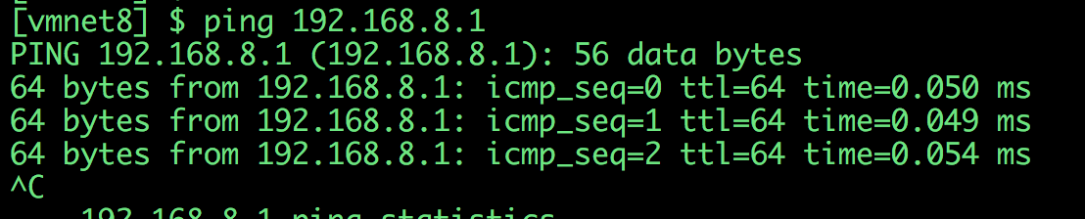

然后在虚拟机菜单中将网络设置为NAT网络即可：

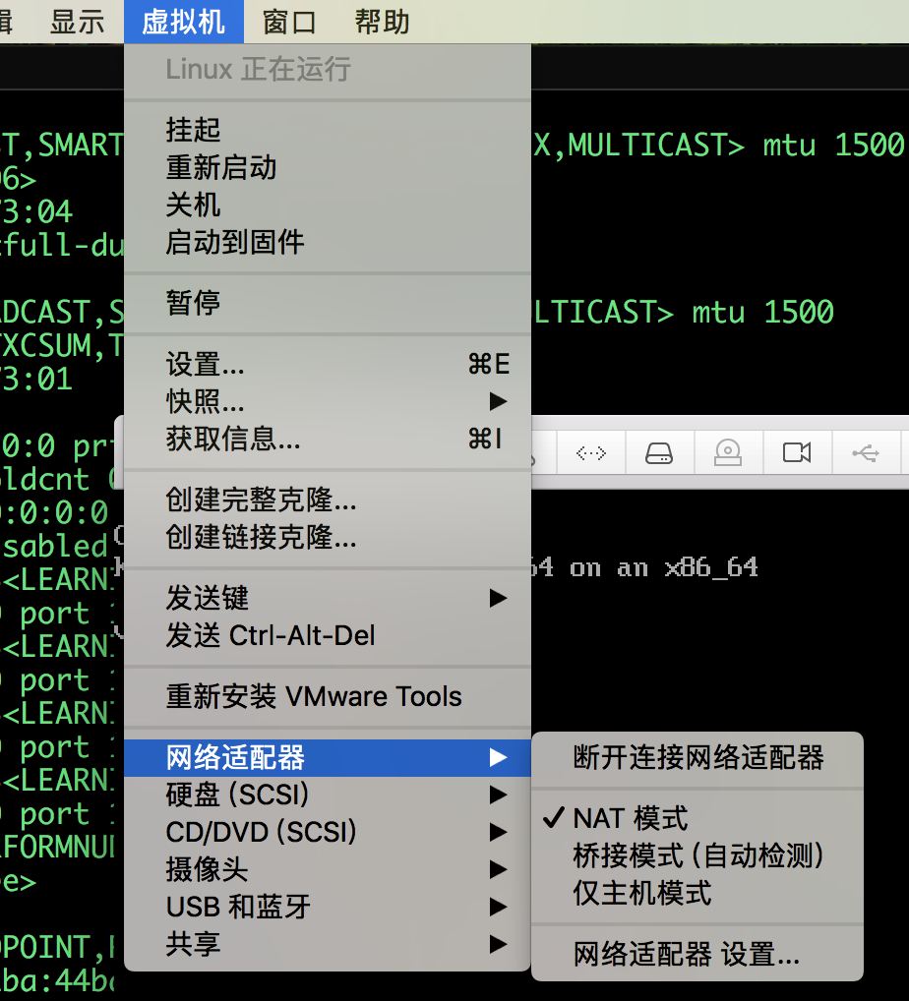

# 2 检查k8s是否正常启动

## 2.1 检查方式

### 确保apiserver启动：

apiserver作为总线，所有的pod和kubelet都要和其打交道，需要确保apiserver启动：

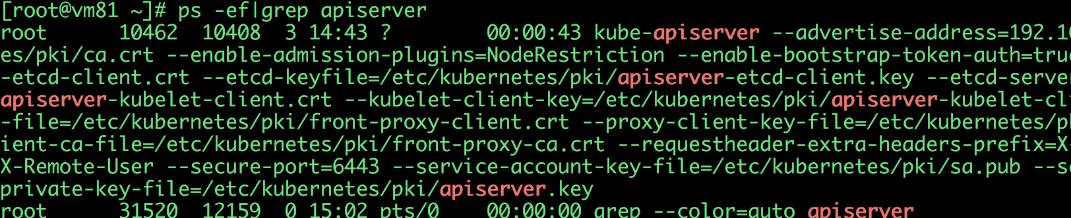

apiserver是部署在k8s pod中的，如果apiserver没有启动，原因可能有：

1. kubelet没有启动
2. kubelet启动了，但是pod没有启动

### 确保kubelet启动：



如果没有启动：执行

**systemctl restart kubelet**

确保k8s的node处于ready状态：

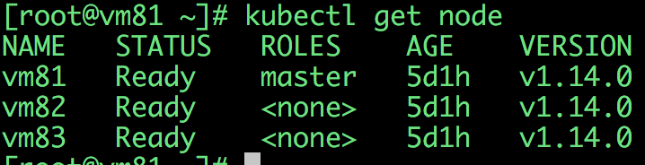

如果node没有处于ready状态，检查pod：

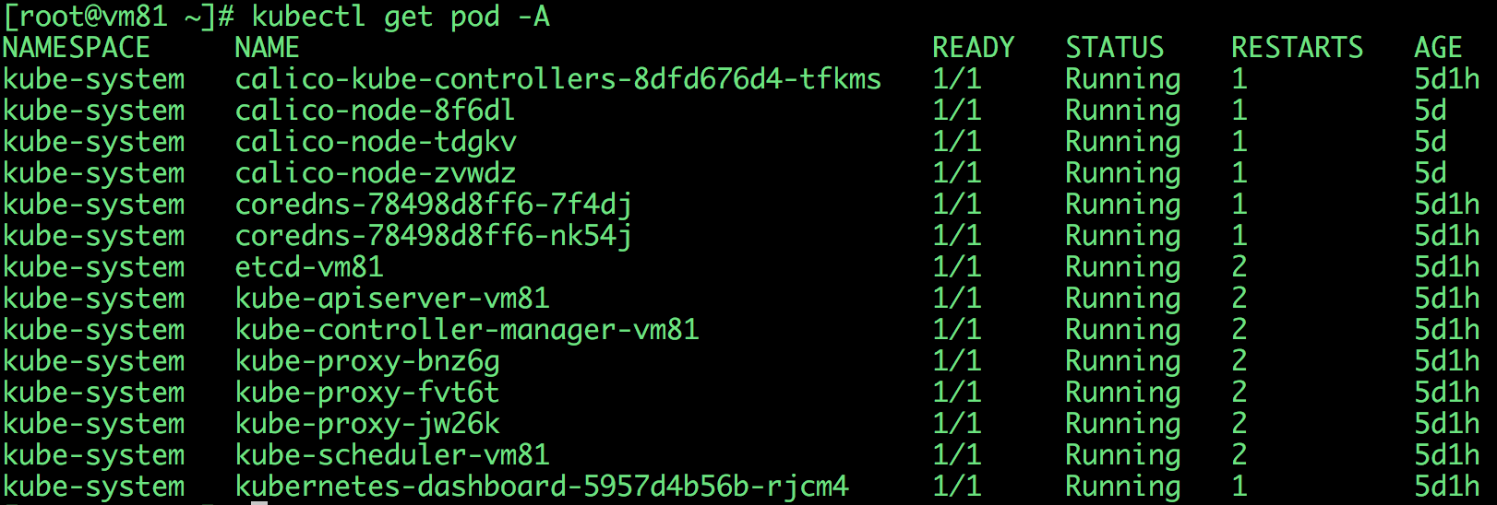

### 检查pod

如果有的pod没有启动，检查pod的状态：

kubectl describe pod pod-XXXXXXX

### 查看日志

如果依然有问题，查看kubelet的日志，看问题针对性的解决：

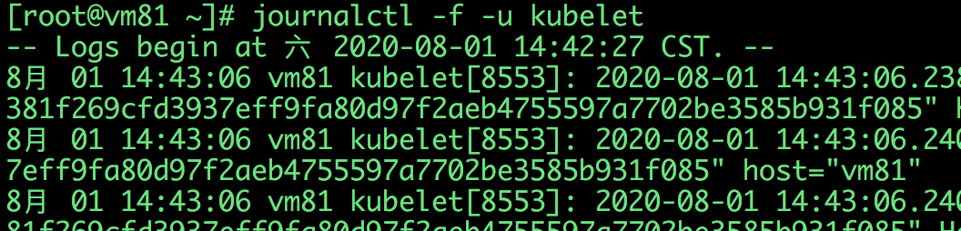

版权所有：有任何问题可以加我微信

